Typical workflow in ENVI-met
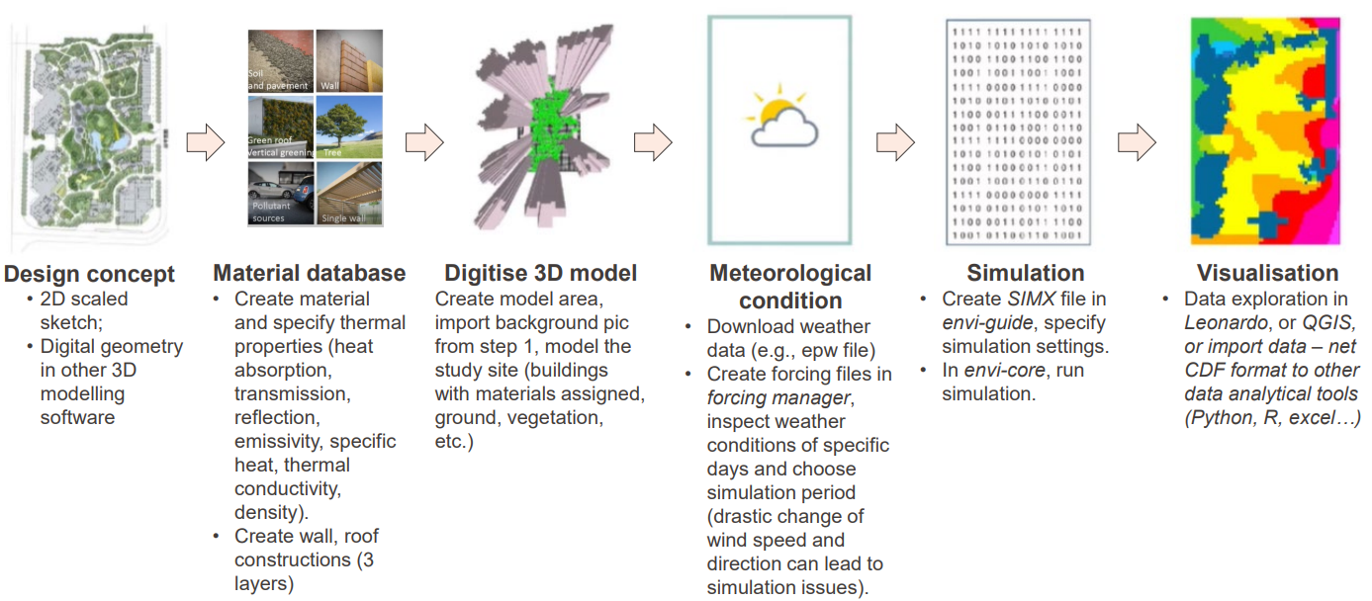
Project workspace:
Getting Started | Designing Your Ideal Workspace #2 (youtube.com)
- Design concept: can come from sketches or existing map. In Demo folder, you will find a background bitmap ‘EPFL innovation park background’ to be used as a reference for creating ENVI-met model for the base case scenario of EPFL innovation park.
- Material database:
Basics:
Project Guide | Urban Material Creation Guide #2 (youtube.com)
Project Guide | Wall Management: Database Manager #3 (youtube.com)
Project Guide | Soils & Profiles: Database Manager #4 (youtube.com)
Project Guide | Simple Plants: Database Manager #5 (youtube.com)
Project Guide | Facade & Roof Greening: Database Manager #6 (youtube.com)
Advanced:
Expert Lesson: Building Physics, 1/3 (youtube.com)
Expert Lesson: Building Physics, 2/3 (youtube.com)
Expert Lesson: Building Physics 3/3 (youtube.com)
- Digitise 3D model
Basics:
Project Guide | Model Area Creation Settings: SPACES #12 (youtube.com)
Project Guide | Object Placement Model Area: SPACES #13 (youtube.com)
Q&A and advanced:
Demo Session | Urban Environment Digitization Guide (youtube.com)
Demo Session | Creating Environments with ENVI-met (youtube.com)
- Metrological condition
Basics
Demo Session | Meteorological Conditions & Full Forcing (youtube.com)
- Simulation
Basics:
(211) Project Guide | Simulation Setup with ENVI-guide #14 - YouTube
- Visualisation
Basic:
(211) Project Guide | Visualization Simulation Output: Leonardo #15 - YouTube
Project Guide | 3D Output Maps Creation: Leonardo #16 (youtube.com)
Demo Session | Model Output Visualization Essentials (youtube.com)
Advanced:
Demo Session | Advanced Data Visualization with LEONARDO (youtube.com)

